AP 185 Activity[1]

**Frequency Response of Systems**

In this experiment we will practice how to obtain the Bode Plot of a system. The Bode Plot represents the frequency response or the DYNAMIC characteristics of a system. The transfer function of a system can be estimated from Bode Plots.

Materials: passive electrical components (resistors, capacitors, inductors.), signal generator, oscilloscope with two probes.

Procedure:

Part A

1. Set up the RLC circuit below (low pass filter ) with R and C of your choosing. Record these values.

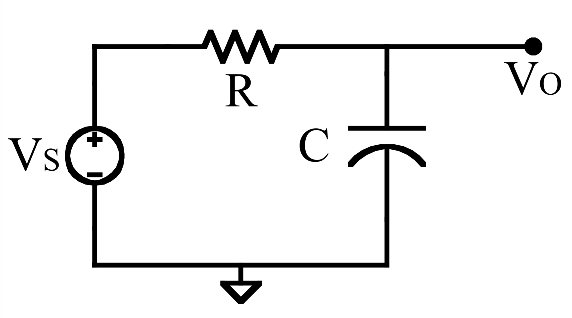

1. Drive the circuit with a sinusoid with frequencies incremented in orders of 10. For example, 10Hz, 100Hz, 1kHz, 10kHz, 100kHz, 1MHz, 10Mhz, 100MHz. For finer increments and a smoother curve, you can also do 10Hz, 50Hz, 100Hz, 500Hz, 1kHz, 5kHz, etc. If you expect resonance, use finer increments.
2. For each frequency, tabulate the amplitude and phase shift of the output sinusoid. You may need to observe input and output signals simultaneously to measure phase shift. At certain frequencies, the output might appear to vanish. Increase the output channel y-axis sensitivity until you see the output signal again.
3. For each frequency, calculate the Gain of the system G = 20 log(Vout/Vin) . Create a plot of G vs. log of frequency and another for phase shift vs. log of frequency similar to the Illustration below. These are called Bode plots.

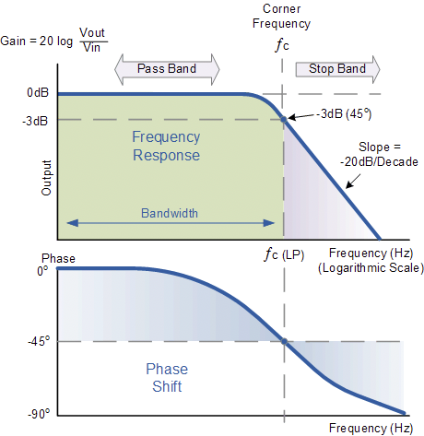

1. Using the same value for R and C, build the following circuits and obtain their Bode plots :

|  |  |
| --- | --- |
| High pass filter | Second order low pass filter |
|  | Second order high pass filter |

1. Estimate the transfer function of the system using the Bode plot. Compare with analytic transfer function computed from your circuit diagram.

Part II. Active Filters

From Bruce Carter, Ron Mancini, in [Op Amps for Everyone (Fifth Edition)](https://www.sciencedirect.com/science/book/9780128116487), 2018 and Hank Zumbahlen, with the engineering staff of Analog Devices, in [Linear Circuit Design Handbook](https://www.sciencedirect.com/science/book/9780750687034), 2008

Second-Order Low-Pass Filter

There are two topologies for a second-order low-pass filter, the Sallen–Key and the multiple feedback (MFB) topology.  
  
Sallen–Key Topology

1. The general Sallen–Key topology in Fig. A allows for separate gain setting via A0 = 1 + R4/R3. The Sallen–Key configuration, also known as a voltage control voltage source (VCVS), was first introduced in 1955 by R.P. Sallen and E.L. Key of MIT's Lincoln Labs uses the op-amp to provide gain and thus does not depend greatly on the op-amp characteristics. To transform the lowpass into the highpass we simply exchange the capacitors and the resistors in the frequency determining network (i.e., not the amp gain resistors).

|  |  |
| --- | --- |
| https://ars.els-cdn.com/content/image/3-s2.0-B9780750687034000080-f08-67-9780750687034.gif  A. General Sallen–Key low-pass filter | https://ars.els-cdn.com/content/image/3-s2.0-B9780750687034000080-f08-68-9780750687034.gif B. General Sallen–Key high-pass filter |

Multiple feedback filter

The multiple feedback filter, a popular configuration, uses an op amp as an integrator instead of just providing gain. The dependence of the transfer function on the op amp parameters is greater than in the Sallen-Key.

|  |  |
| --- | --- |
| 1. Multiple feedback low pass | 1. Multiple feedback high pass |

Activity

1. Keeping the cutoff frequency near the previous activity’s values, design the following by picking the correct capacitor:
   1. Multiple feedback low pass
   2. Multiple feedback high pass
   3. Sallen Key low pass
   4. Sallen Key high pass
2. Repeat the previous activity for the active filters and obtain their Bode plots.
3. Estimate the transfer function of the system using the Bode plot. Compare with analytic transfer function computed from your circuit diagram.

1. From Dr. MSoriano 185 activities